 **University of Haripur**

Department of Information Technology

Program: BSAI

|  |  |  |  |  |
| --- | --- | --- | --- | --- |
| Course Number | |  | | |
| Section Number | | **BSAI- 2nd** | | |
| Course Title | | **Database System** | | |
| Semester/Year | | **Fall 2020** | | |
| Instructor | | **Sadaqat Ali** | | |
| **ASSIGNMENT No.** | | **03** |
| Submission Date | | **24 DEC 2020** | | |
| Due Date | | **25 DEC 2020** | | |
| Student Name | | **Momin Hayat Khan** | | |
| Student Reg. No | | **S20-0273** | | |
| Signature* | | **Momin** | | |

*\*By signing above you attest that you have contributed to this submission and confirm that all work you have contributed to this submission is your own work. Any suspicion of copying or plagiarism in this work will result in an investigation of Academic Misconduct and may result in a “0” on the work, an “F” in the course, or possibly more severe penalties.*

STUDENT RECORD KEEPING SYSTEM

App Design

Name: Momin Hayat Khan RegNo: S20-0273

**About Project:**

Hello myself Momin, Student of BS ( A.I ) 2nd semester. I’m making an application for school for record keeping system database in Microsoft SQL Server because in school there are a lot of students and teachers are have a lot of data regarding to grades , attendance ,fees and salary etc. To manage them manually is really difficult task and require a lot of time and effort and suddenly when we need a data about particular student or teacher It is so difficult to find them from register and took a lot of time and effort. With my database system this problem will be resolved user just need to enter the roll no or id of student/teacher and he/she can access all the data about that particular student.

**Login Page:**

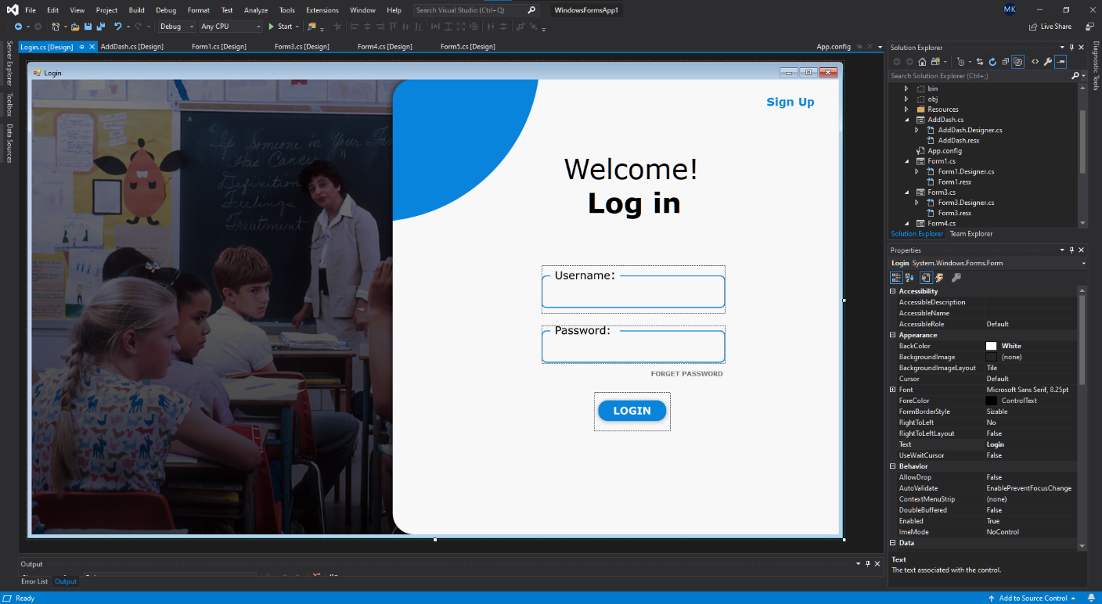

**Code:**

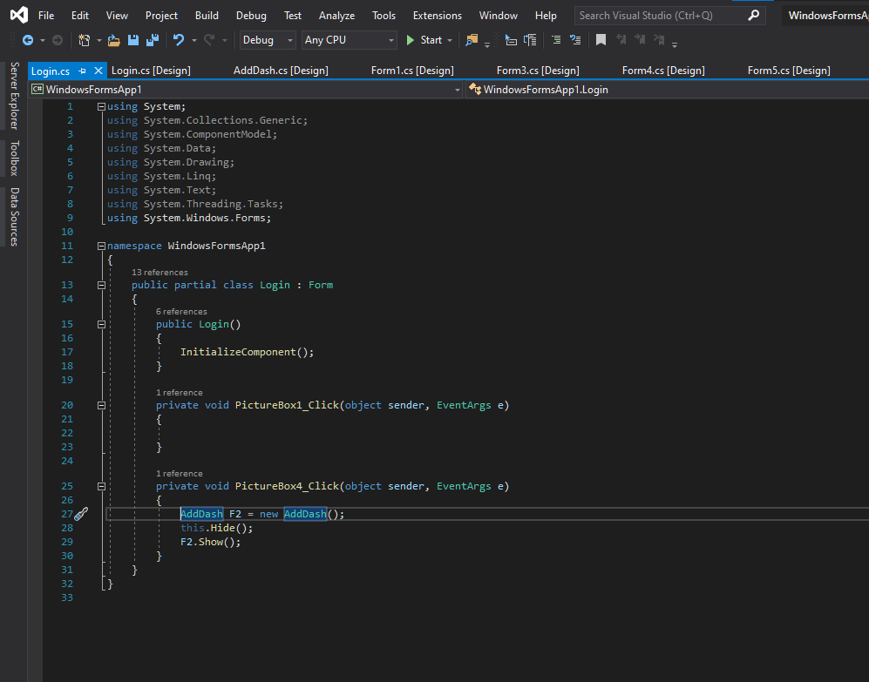

**Dashboard (ADD):**

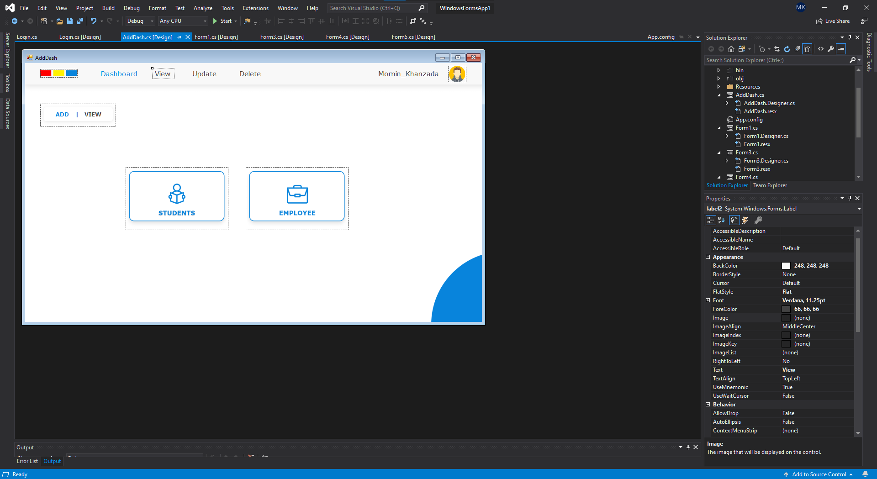

**Code:**

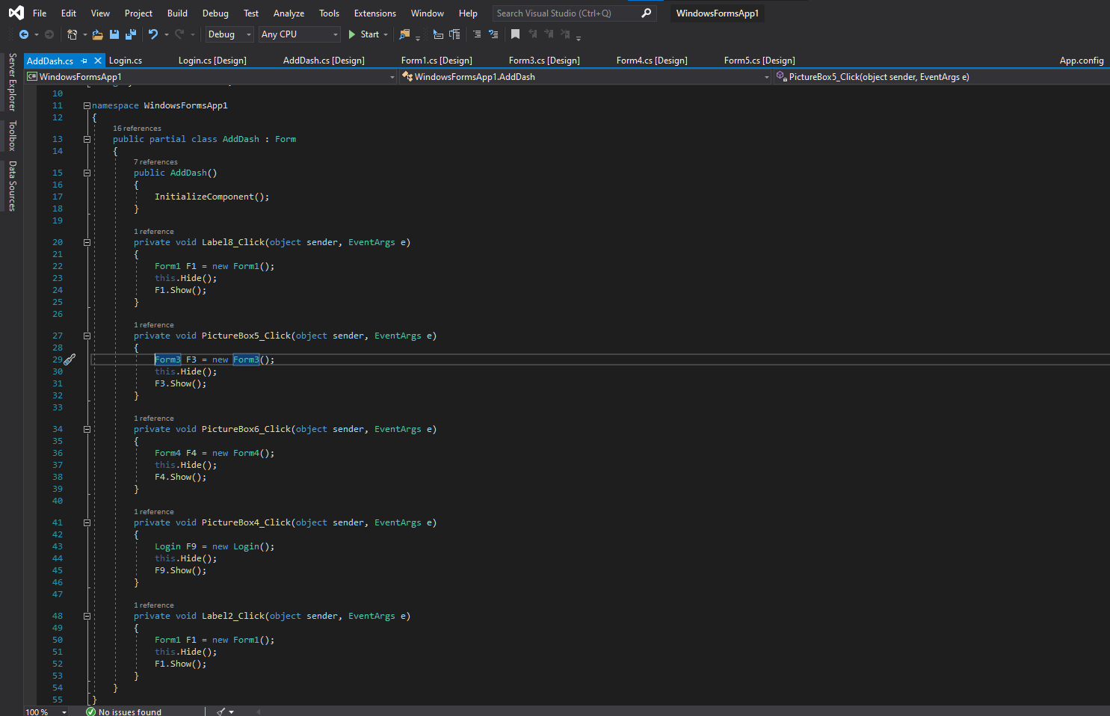

**Dashboard (VIEW):**

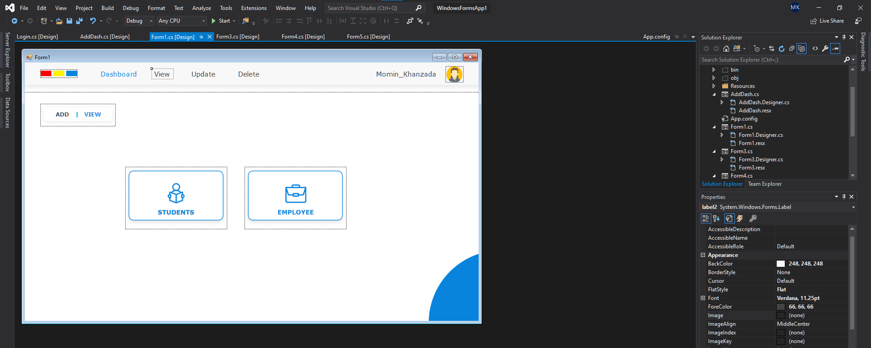

**Code:**

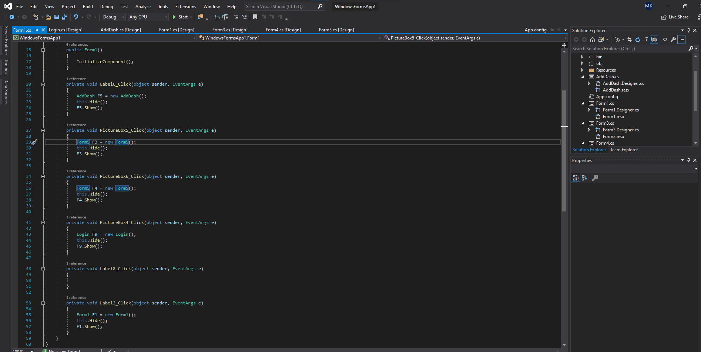

**Adding Student Record:**

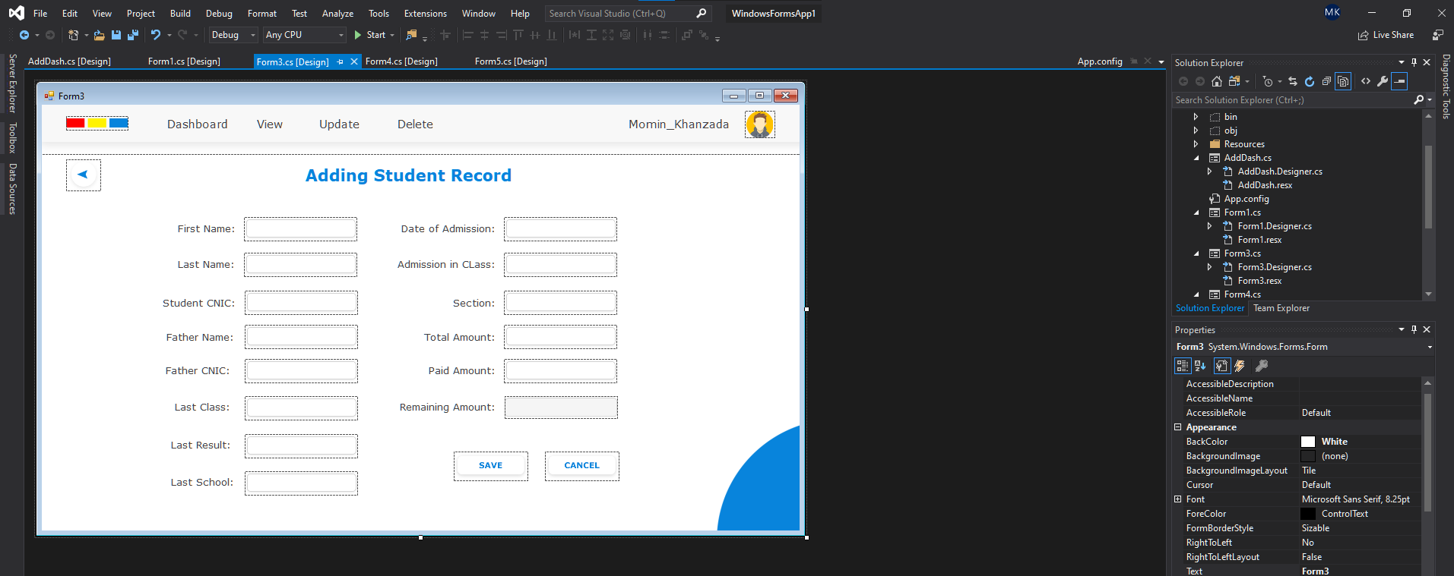

**Code:**

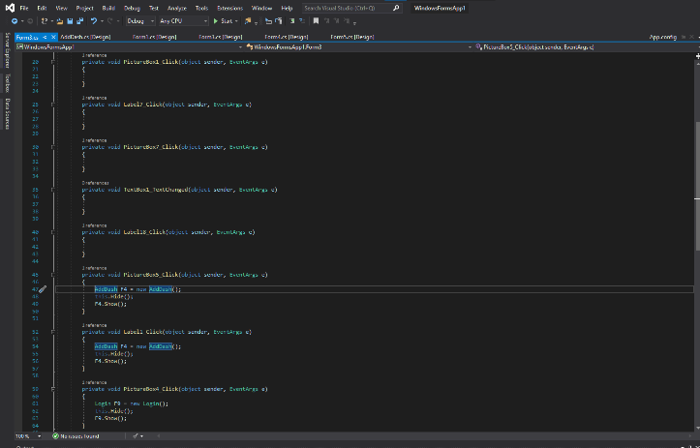

**Adding Employee Records:**

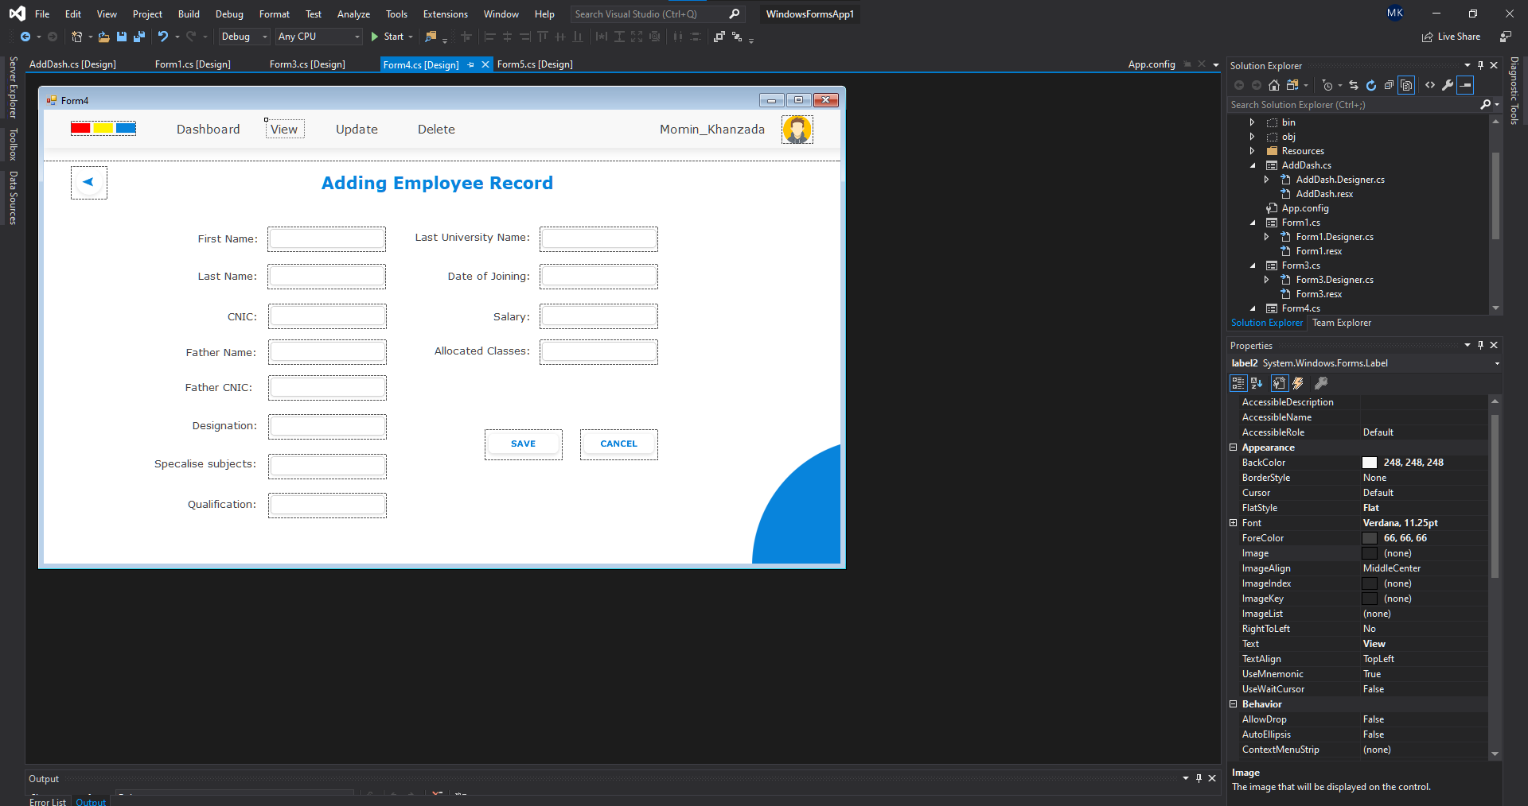

**Code:**

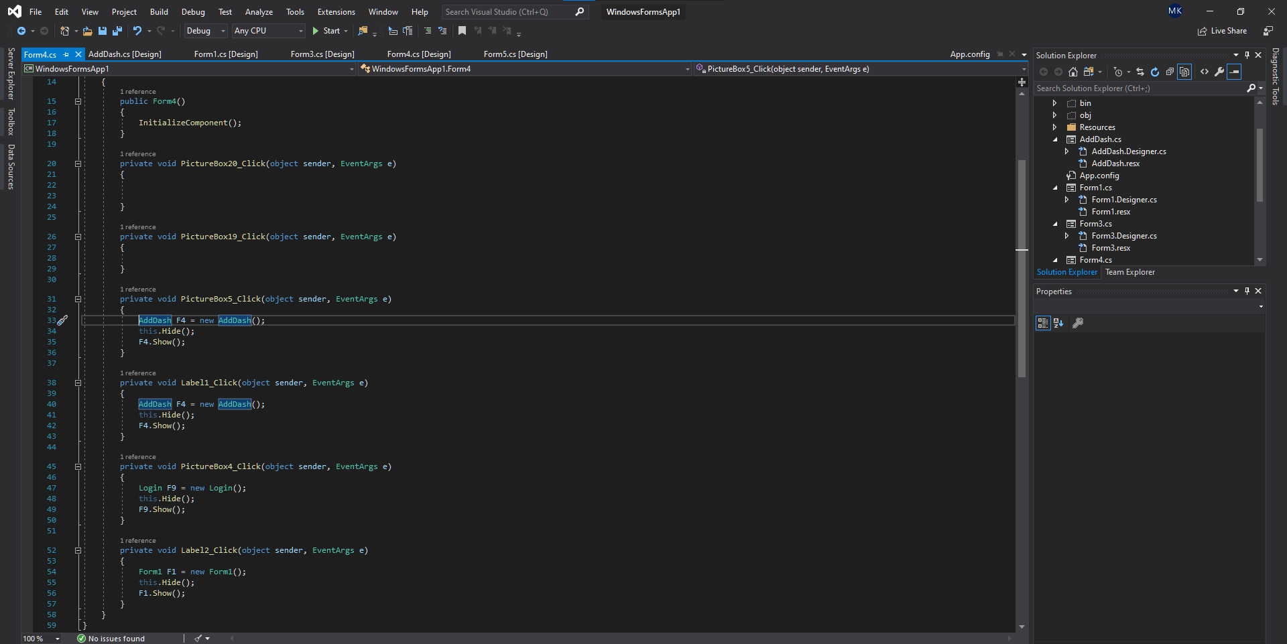

**Viewing Record:**

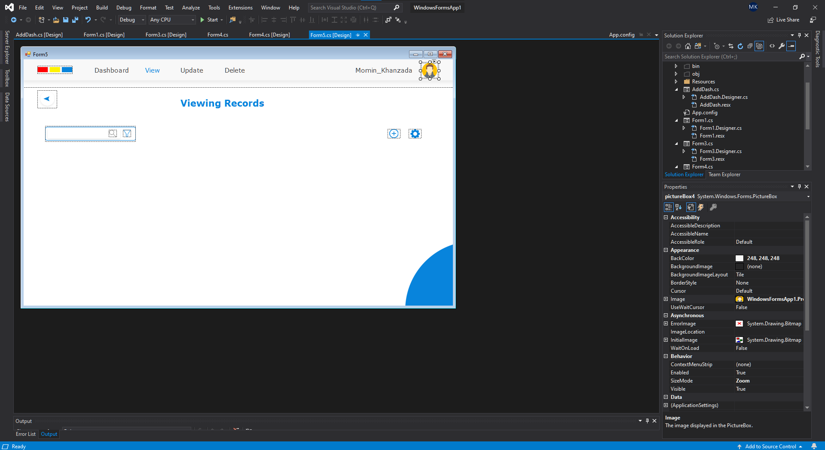

**Code:**

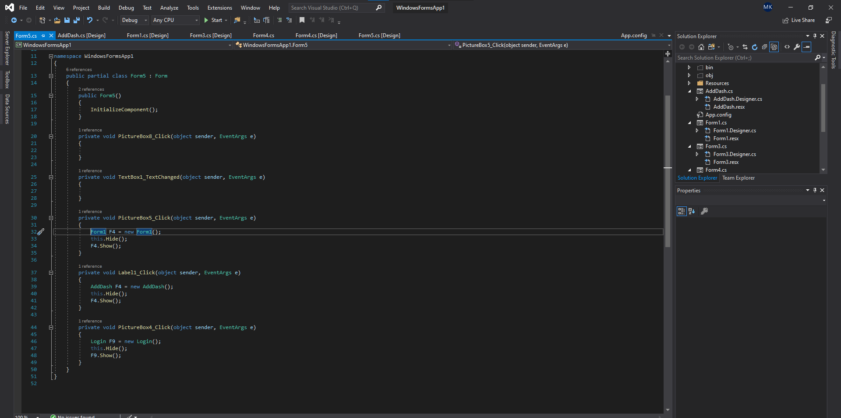

**Debugging Application:**

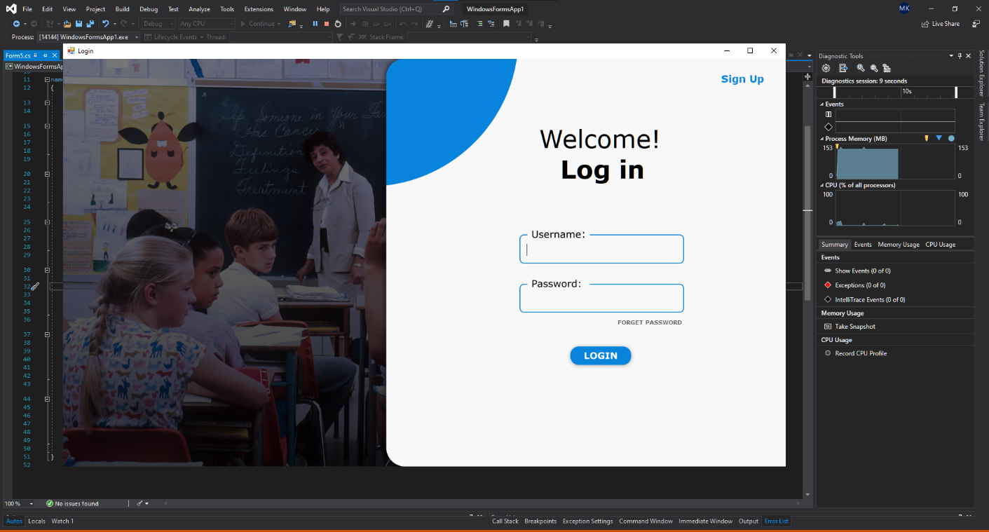

**Code:**

